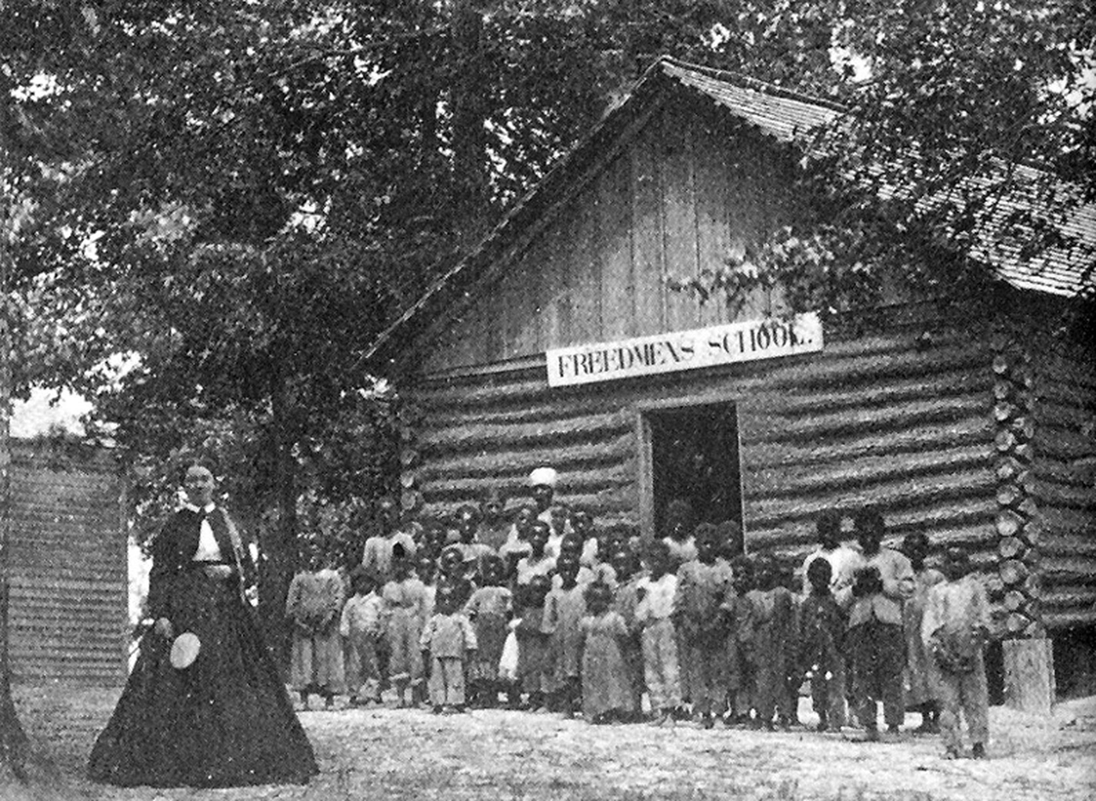
History of Education Society
55th Annual Meeting
November 5–8, 2015
St. Louis Hilton at the Ballpark
St. Louis, Missouri

HISTORY OF EDUCATION SOCIETY
F
ounded in 1960, HES is an international scholarly organization that encourages research in the history of education, publishes the History of Education Quarterly, hosts an annual conference every fall, fosters the teaching of the history of education in colleges and universities, highlights the value of historical perspective in the creation of educational policies, and promotes library and museum facilities for the preservation of primary source materials.

ENDOWMENT FUND
P
lease consider contributing to the Endowment Fund this year. The HES uses the fund to help subsidize conference costs incurred by graduate students and unemployed historians. Please send your tax-deductible contributions to Ralph Kidder, HES Treasurer, 2020 Chadds Ford Drive, Reston, VA 20191. For information on other ways to donate to HES, including bequests and planned giving, contact Ralph at: historyofedsociety@gmail.com

COVER PHOTO
“James’s Plantation School” in Pitt County, North Carolina, 1866. An engraving of this image appeared in the October 3, 1868 issue of Harper’s Weekly accompanying an article entitled “The Freedmen’s Schools.”
Credit: North Carolina Collection Photographic Archives/University of North Carolina at Chapel Hill, Louis Round Wilson Library.

An online copy of the program is available at http://historyofeducation.org

History of Education Society
55th Annual Meeting
November 5–8, 2015

CONFERENCE SPONSORS
University of Wisconsin–Madison: Wisconsin Center for Education Research (WCER)
Washington University–St. Louis: Dean of the Faculty of Arts & Sciences, Departments of Education and History, and Program on Women, Gender, and Sexuality Studies
University of Iowa: College of Education
PROGRAM CHAIR
Adam R. Nelson, University of Wisconsin–Madison
PROGRAM COMMITTEE
Jon Hale, College of Charleston
Jonna Perrillo, University of Texas, El Paso
Tracy Steffes, Brown University
Roberta Wollons, University of Massachusetts, Boston
PROGRAM ASSISTANCE
From the University of Wisconsin–Madison:
Brett Bertucio, Erin Hardacker, Liu Qing, Eric Luckey, Amato Nocera
Kyle Steele, Nick Strohl, Sun Bi, Wang Huimin, Carrie Welsh
BOOK EXHIBIT DIRECTOR
Deanna Michael, University of South Florida, St. Petersburg
GRADUATE STUDENT COMMITTEE
Alisha Johnson, University of Illinois, Urbana–Champaign
Jean Park, Teachers College, Columbia University
Jessica O’Brien Pursell, Southern Illinois University
Keegan Shepherd, University of South Florida
Rebecca Wellington, University of Washington
Sean Owczarck, University of Wisconsin–Madison

Special Thanks
Susan Berger, National University
Abbie Keenoy, St. Louis Hilton at the Ballpark

HISTORY OF EDUCATION SOCIETY
OFFICERS, 2015–2016

President
Christine A. Ogren, University of Iowa
Past President
James W. Fraser, New York University
Vice President and Program Chair
Adam R. Nelson, University of Wisconsin–Madison
Vice President-Elect
Jackie Blount, The Ohio State University
Treasurer
Ralph Kidder, Marymount University
Secretary
Karen Graves, Denison University
Board of Directors
Sevan Terzian, University of Florida (2013–2015)
Margaret Nash, University of California, Riverside (2014–2016)
Carter Savage, Morehouse College (2015-2017)

HISTORY OF EDUCATION QUARTERLY EDITORIAL STAFF
(Incoming, Volume 56 [2016])

Senior Editor
Nancy Beadie, University of Washington, Senior Editor
Co-Editor
Joy Williamson-Lott, University of Washington, Associate Editor
Book Review Editor
Isaac Gottesman, Iowa State University
Editorial Assistants
Kathryn Nicholas, University of Washington
Jennifer Gallagher, Iowa State University
Editorial Board
Ansley T. Erickson, Teachers College Columbia University
G. Antonio Espinoza, Virginia Commonwealth University
Adrea Lawrence, University of Montana
Christopher Loss, Vanderbilt University
John Murray, Rhodes College
Tracy L. Steffes, Brown University

The new editors of History of Education Quarterly express deep esteem and appreciation for the strong leadership and stewardship of the journal by the University of Illinois editorial team and for the many scholars who served on the editorial board and contributed to HEQ as reviewers over the last ten years.

Outgoing Editors (2015)
James D. Anderson, University of Illinois, Urbana–Champaign
Yoon K. Pak, University of Illinois, Urbana–Champaign
Christopher Span, University of Illinois, Urbana–Champaign
Timothy R. Cain, University of Georgia, Book Review Editor

HISTORY OF EDUCATION SOCIETY COMMITTEES

CLAUDE A. EGGERTSEN DISSERTATION PRIZE AWARD COMMITTEE
Louis Ray, Farleigh Dickinson University, Chair
Kelly Kish, Indiana University
Victoria Cain, Northeastern University

PRIZE COMMITTEE—HISTORY OF EDUCATION SOCIETY AWARD
Diana D’Amico, George Mason University, Chair
Jonna Perrillo, University of Texas, El Paso
Tracy Steffes, Brown University

OUTSTANDING BOOK AWARD COMMITTEE
Margaret Nash, University of California, Riverside, Chair
Ansley Erickson, Teachers College, Columbia University
Charles Dorn, Bowdoin College

LINDA EISENMANN PRIZE COMMITTEE
(Prize awarded in even years only; to be awarded again in 2016)

ARCHIVES COMMITTEE
Mary Ann Dzuback, Washington University, Chair
Nancy Beadie, University of Washington
Marc VanOverbeke, Northern Illinois University

TEACHING OF THE HISTORY OF EDUCATION COMMITTEE
Jon Hale, College of Charleston, Chair
Jana Nidiffer, Oakland University
Campbell Scribner, Ohio Wesleyan University
Michael Bowman, University of Washington, Graduate Student Representative

TECHNOLOGY COMMITTEE
Christine Woyshner, Temple University, Chair
Andrew Grunzke, Mercer University
Gonzalo Guzman, University of Washington

DEVELOPMENT COMMITTEE
Ralph Kidder, Treasurer and Chair
Robert Hampel, University of Delaware
Linda Eisenmann, Wheaton College

NOMINATING COMMITTEE
James Fraser, New York University, Past President and Chair
Adah Ward Randolph, Ohio University, Past Past President
Jana Nidiffer, Oakland University
Michelle A. Purdy, Washington University in St. Louis
Kathryn Nicholas, University of Washington, Graduate Student Representative

UPCOMING CONFERENCES

HISTORY OF EDUCATION SOCIETY

2016
Providence, Rhode Island
Renaissance Providence Downtown Hotel
November 3–6

2017
Little Rock, Arkansas
Little Rock Marriott Hotel
November 1–5

Southern History of Education Society
Long Beach, Mississippi
March 11–12, 2016

American Educational Research Association
Washington, DC
April 8–12, 2016

International Standing Conference for the History of Education
Chicago, Illinois
August 17–20, 2016

Organization of Educational Historians
Chicago, Illinois
September 23–24, 2016

Canadian History of Education Association
Waterloo, Ontario, Canada
October 27-30, 2016

LOCATION OF 55TH ANNUAL HES MEETING

Conference rooms are located on the Lobby Level and Meeting Room Level (up one floor)

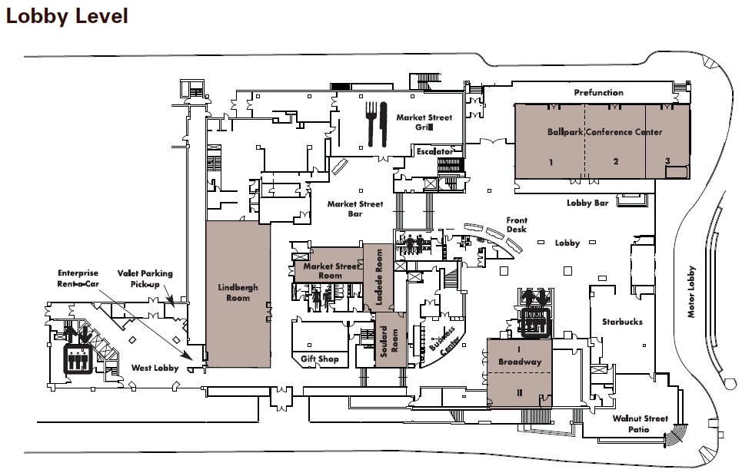
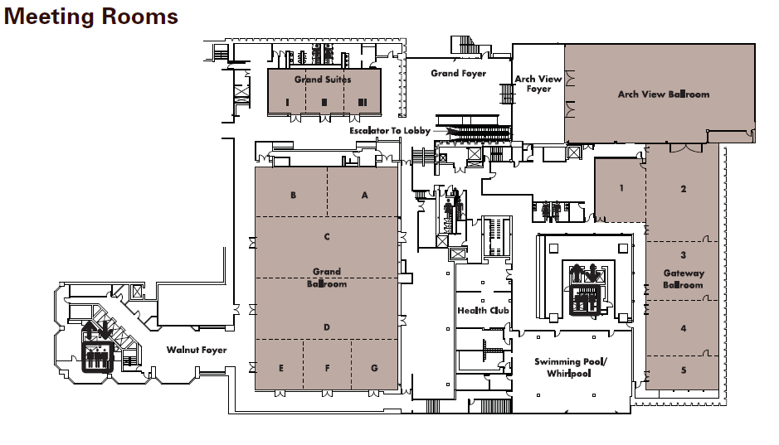
LOCATION OF THE ST. LOUIS HILTON-BALLPARK
AND NEARBY HOTELS
St. Louis Hilton-Ballpark, Union Station Doubletree, Drury Plaza, Hyatt Regency Riverfront, Crowne Plaza Downtown, Hilton Downtown, Drury Inn and Suites, Hampton Inn, Embassy Suites, Renaissance Grand
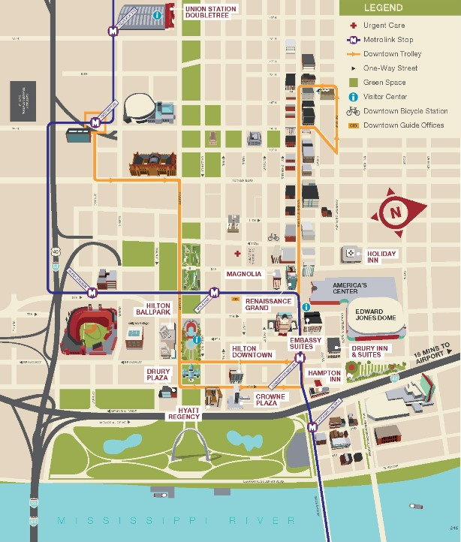
SCHEDULE OF EVENTS
History of Education Society
55th Annual Meeting
November 5–8, 2015
St. Louis Hilton at the Ballpark
St. Louis, Missouri
TIME LOCATION
THURSDAY, NOVEMBER 5
8:00 a.m. to 5:00 p.m. History of Education Society Board Meeting Gateway 3
Christine A. Ogren, University of Iowa, President
12:00 p.m. to 5:00 p.m. Conference Registration Broadway
Ralph Kidder, Marymount University, Treasurer
and the HES Graduate Student Committee
1:00 p.m. to 2:30 p.m. CONCURRENT SESSIONS

Women’s Colleges in the United States and Canada Gateway 1
Chair and Discussant: Mary Ann Dzuback, Washington University in St. Louis
- Useful Ornaments: Form and Function of a Demill Ladies College Education
Laura Suchan, Oshawa Community Museum, Oshawa, Ontario
- Virginia Gildersleeve and the Making of Modern Women’s College Education
Patrick Dilley, Southern Illinois University, Carbondale
- No Need for Intervention: Women’s Colleges’ Ideological and Pragmatic Concerns during the Establishment of Federal Aid, 1933–1943
Jon Gorgosz, Southern Illinois University, Carbondale
- Student Protest and Activism at Bennett College for Women, 1930–1960
Deidre Flowers, Teachers College, Columbia University

The Politics of Music Education: Cross-National Perspectives, 1900–1950 Gateway 4
Chair and Discussant: Yoon Pak, University of Illinois, Urbana–Champaign
- Conservatory for a New World: Jeannette Meyers Thurber and the National Conservatory of Music of America
Lee Bynum, Columbia University
- Sounds of Change: Nation Building through Music Textbooks in the Early Turkish Republic
Faith J. Childress, Rockhurst University
- “When We Sing Together”: Zilphia Horton and the "Folk Approach" of Highlander Folk School, 1935-1956
Carrie Ann Welsh, University of Wisconsin–Madison

Contesting Interwar Modernity: From Vamps to Vampires Gateway 5
Chair and Discussant: William Reese, University of Wisconsin–Madison
- The Schoolmarm Bobs her Hair: Teacher Resistance to Dress Codes in Early 20th Century United States
Patricia Carter, Georgia State University
- Conceptions of “Modernity” in Interwar Period Higher Education
Jacob Hardesty, Rockford University
- An Education in the “Unspeakable”: Manly Wade Wellman, the Origins of Southern Gothic, and the Rise of the High School Vampire
Andrew L. Grunzke, Mercer University

Practicum on Publishing in the Field of Education History and Beyond… Market
Chair: Alisha Johnson, University of Illinois, Urbana–Champaign
- Nancy Beadie, University of Washington
- Isaac Gottesman, Iowa State University
- Dave Robertson, University of Missouri, St. Louis
**Hosted by the Graduate Student Committee

THURSDAY, continued
2:45 p.m. to 4:15 p.m. CONCURRENT SESSIONS

Assessing Administrators: American University Presidents at Mid-Century Gateway 1
Co-Chairs and Co-Discussants: Nathan Sorber, West Virginia University; and Bruce Leslie, SUNY–Brockport
- Assessing a University Presidency: James Bryant Conant and Harvard University, 1933–1952
Wayne J. Urban, University of Alabama
- From Student Leader to University President: George W. Rightmire of Ohio State University
Benjamin A. Johnson, Utah Valley University
- Reinert as Servant Leader: Reflections on Fr. Paul Reinert’s Leadership at Saint Louis University
Maureen Wangard, St. Louis University

Race, Religion, and Science Curricula in the U.S., Colombia, and Brazil Gateway 4
Co-Chairs and Co-Discussants: Noah Sobe, Loyola University Chicago; and Victoria Cain, Northeastern University
- The Mathematics Education of Blacks before Brown: An Examination of Mathematics Curriculum in Industrial Schools in the Segregated South, 1854–1954
Nicole Joseph, University of Denver
- Nihil obstat: “Natural Theology”’ across Biology Textbooks in Colombia 1870–1970
Gonzalo J. Peñaloza, Universidad Distrital Francisco José de Calda, COLOMBIA
- Reviewing the “Intuitive Method” and “Object Lesson” in Brazil by the Late 19th and Early 20th Century
Mirian Warde, Federal University of São Paulo, BRAZIL (UNIFESP)

Education as a Human Right: International, Intellectual, and Soulard
Institutional History
Chair and Discussant: Mark Johnson, University of Wisconsin–Madison
- Humanism and the Concept of Education as a Human Right: Tracing a UNESCO Tradition
Maren Elfert, University of British Columbia, CANADA
- The Universality of Individuality: Citizenship, Nationalism and the Invention of the Human Right to Education
Glenn Mitoma, University of Connecticut

Interrogating the Campus Novel: Gender in American, Market
British, and Canadian Academic Fiction, Postwar to the Present
Chair and Discussant: Linda Eisenmann, Wheaton College
- Love and Desire on Campus: Constance Beresford Howe’s Of This Day’s Journey (1947)
E. Lisa Panayotidis, University of Calgary, CANADA
Paul Stortz, University of Calgary, CANADA
- Slashing University Education: Women’s Academic Crime Fiction in Thatcher’s Britain
Ann McClellan, Plymouth State University
- Dirigibles, Detectives & Degrees: A Steampunk Look at Victorian Higher Education for Women
Christine D. Myers, Monmouth College

THURSDAY, continued
4:30 p.m. to 6:00 p.m. CONCURRENT SESSIONS

Religion and Education in New York Gateway 1
Chair and Discussant: Adam Laats, Binghamton University
- St. Philip’s Episcopal Church and Education in Harlem
Jennifer K. Boyle, Teachers College, Columbia University
- The Greek Orthodox Church and Education in New York, 1959–1985
Fevronia Soumakis, Teachers College, Columbia University

Book Panel: Kelly Sartorius, Deans of Women and the Feminist Movement Gateway 4
Chair: John Rury, University of Kansas
Deans of Women and the Feminist Movement: Emily Taylor’s Activism (Palgrave MacMillan, 2014)
- Jackie Blount, Ohio State University
- Andrea Walton, Indiana University
- Jana Nidiffer, Oakland University
Response: Kelly Sartorius, Washington University in St. Louis

Archival Histories of Composition and Rhetoric in Gateway 5
Normal Schools and Teacher Institutes in the U.S. and Japan
Chair and Discussant: Kelly Ritter, University of Illinois, Urbana–Champaign
- Reforming Writing Instruction: Curricular and Pedagogical Innovations at the Illinois State Normal University, 1899–1916
Lori Ostergaard, Oakland University
- “To Be in Sympathy”: Normal School Discourse, Teachers as Researchers, and Conceptions of the Child
Beth Ann Rothermel, Westfield State University
- Nineteenth-Century California Teachers’ Institutes: Exploring Connections among Teachers’ Institutes, Normal Schools, and Elite Eastern Colleges
Suzanne Bordelon, San Diego State University
- Writing Lives, Composing Community: Locating “Life Writing” Pedagogy in Japanese Education History, 1920–1937
Patrick Shorb, Akita International University, JAPAN

Health, Gender, and Teaching in Early America Market
Chair and Discussant: Margaret Nash, University of California, Riverside
- The Fragile Wellness of Scholars: How European Medicine and Education Shaped American School Health
Rebecca R. Noel, Plymouth State University
- “My School Is . . . Exceedingly Laborious”: The Bonds of Teaching in the Early Republic
Rob Koehler, New York University
- “Pioneering Female Educators: Lydia Huntley Sigourney and Catharine Beecher”
Susan J. Berger, National University

Ahem… is this thing on?: Conference Presentation Skills Workshop Soulard
Chair: HES Graduate Student Committee
This interactive session will focus on helping anyone who feels they would like to improve their presentation skills. We will share best practices and, most importantly,
we will practice. If you have material on which you would like to work, we encourage you to bring it.
**Hosted by the Graduate Student Committee
THURSDAY, continued
6:00 p.m. to 7:30 p.m. Welcome Reception Arch View Ballroom

8:00 p.m. SPECIAL AFTER-DINNER FILM SCREENING Gateway 4

HES after Dark: A Screening and Discussion of the Marx Brothers’
1932 Film Horse Feathers
Co-Chairs and Co-Discussants: Jacob Hardesty, Rockford University; and Andrew Grunzke, Mercer University

FRIDAY, NOVEMBER 6
8:00 a.m. to 4:00 p.m. Conference Registration Broadway
9:00 a.m. to 5:00 p.m. Book Exhibit Broadway

8:30 a.m. to 10:00 a.m. CONCURRENT SESSIONS

Ferguson History: Race, Citizenship, and Politics of Gateway 1
Education in St. Louis, Missouri
Chair and Discussant: Karen Graves, Denison University
- Advocating for Educational Equity: African American Citizens’ Councils in St. Louis, Missouri, 1864 to 1927
Melanie Adams, Missouri History Museum
- The 40-year Quest to Elect an African American to the St. Louis Board of Education: An Early Snapshot of the Civil Rights Movement Outside the Deep South
Claude Weathersby, Independent Scholar
- Disappointment Came in Three’s: The Relationship Between the Former Mayor and the Black Community
Harolyn P. Harris, University of Missouri–St. Louis

Higher Education and the Forming of American Citizens, 1955–2000 Gateway 4
Chair: Hilary Moss, Amherst College
Discussant: Christopher Loss, Vanderbilt University
- “I Ain’t Marching Anymore”: Masculine Citizenship and the End of Compulsory ROTC at American Universities, 1955–1965
Amy Rutenberg, Iowa State University
- Citizens in Bloom: A Legacy Preserving the Great Books
Mark Hlavacik, University of North Texas
- “Citizens in the Fullest Sense”: The University of South Florida during Higher Education’s Golden Age
Charles Dorn, Bowdoin College
- The Rise of Deliberative Democratic Citizenship Education in the Late Twentieth Century
Ethan Schrum, Azusa Pacific University

Testing Limits: The Cultural History of Standardized Gateway 5
Exams in the Twentieth Century
Chair and Discussant: Ethan Hutt, University of Maryland
- Reasons for Reticence: Dynamics of Implementing Educational Testing in American Rural Schools, 1908–1930
Brett Bertucio, University of Wisconsin–Madison
- Productive Liberation: E. P. Torrance and the Search for Creativity
Samuel Franklin, Brown University
- Transparency Laws, Test Prep, and Technology: The Turning Points for College-Entrance Standardized Testing, 1977–1989
Keegan Shepherd, University of South Florida
- From Cultural Assimilation to Cultural Transmission: The History and Impact of Korean “Cram Schools” in New York City
Jean Park, Teachers College, Columbia University

Entre Mujeres: Living and Learning in Chicago Market
Chair and Discussant: Carlos Blanton, Texas A&M University
- Looking Forward, Working for Change: Puerto Rican Women and the Quest for Educational Justice in 1960s Chicago
Mirelsie Velazquez, University of Oklahoma
- Situating our Voices, Locating our Sense of Place: Women’s Stories in 1950s Chicago Schools
Angelica Rivera, Northeastern Illinois University
- Que chulada de mujer: A Mother’s Oral History Told by her Son
Gabriel Rodriguez, University of Illinois, Urbana–Champaign

Race, Gender, and Philosophies of “Progressive” Education Gateway 5
Chair and Discussant: Karen Benjamin, St. Xavier University
- The Complete Published Writings of Ella Flagg Young
Jackie Blount, Ohio State University
- The Doubts of Service-Learning Past (and Present): Irving Babbitt, Charles W. Eliot, and John Dewey
Kip Smilie, Missouri Western State University
- “From the Time of Socrates Down to the Day of Dewey”: Carter G. Woodson’s Philosophy and Critique of Progressive Education
Jarvis R. Givens, University of California, Berkeley
- The Practical Pedagogue: Mary McCleod Bethune’s Evolving Educational Philosophy, 1904–1920
Alexander Hyres, University of Virginia

Antebellum Education: Abolitionism, Sectionalism, and Schools Laclede
Chair and Discussant: William Link, University of Florida
- Common Schools, That Peculiar Yankee Institution
Mark Groen, California State University, San Bernardino
- Fit for Freedom? Inherent Contradictions in the Pennsylvania Abolition Society’s Mission for Free Black Education in Early National Philadelphia
Elise Kammerer, University of Cologne, GERMANY
- “Free from any Expense Whatsoever”: An analysis of the Longevity of Charleston’s Public Schools, 1812–1862
Kim Tolley, Notre Dame de Namur University

FRIDAY, continued

10:15 a.m. to 11:45 a.m. CONCURRENT SESSIONS

New Histories in Literacy Education and Political Activism Gateway 1
Chair and Discussant: Jonna Perrillo, University of Texas, El Paso
- Crucibles of Difference: African American Women’s Political, Social and Spiritual Literacy Activism (1957–1962)
Rhea Estelle Lathan, Florida State University
- Women Learning Freedom in Post-Reconstruction America
Janaka Lewis, University of North Carolina at Charlotte
- “That Strange Phenomenon”: Rethinking Elocution and American Women’s Oratorical Education
David Gold, University of Michigan

New Approaches to Latino/a Education in the Twentieth Century Gateway 4
Co-Chairs and Co-Discussants: Guadalupe San Miguel, University of Houston; and Ruben Flores, University of Kansas
- “We Improvised”: Informal Education in Mexican Barrios in the Midwest, 1910–1955
Caran Howard, University of Iowa
- A Father and Daughter Challenge School Segregation in Washington, D.C.: The “Freak” Case of Karla and Ernesto Galarza, 1947
David G. García, University of California, Los Angeles
Ryan E. Santos, University of California, Los Angeles

Book Panel: Geraldine Jonçich Clifford, Those Good Gertrudes Gateway 5
Chair: Kim Tolley, Notre Dame de Namur University
Geraldine Jonçich Clifford, Those Good Gertrudes: A Social History of Women Teachers in America (Johns Hopkins University Press, 2014)
- Margaret A. Nash, University of California, Riverside
- James Albisetti, University of Kentucky
- Linda M. Perkins, Claremont Graduate University
- Mary Ann Dzuback, Washington University in St. Louis
- Kate Rousmaniere, Miami University, Ohio

Roundtable Discussion: This American Life, Religion, and Market
Regulation in American Public Schools
A recent episode of This American Life focused on the school district in East Ramapo, New York, where a well-organized bloc of Hasidic Jews, denied public funds for their yeshivas, has taken over the school board and slashed the public school budget. This roundtable will allow participants to ask new questions about periodization and long-term change in American school governance, as well as the role of historical evidence in modern policy discussions. Audience members are encouraged to listen to the This American Life podcast before attending the session.
(http://www.thisamericanlife.org/radio-archives/episode/534/a-not-so-simple-majority )
- James Fraser, New York University
- Robert Gross, Sidwell Friends School
- Mike Johanek, University of Pennsylvania
- Benjamin Justice, Rutgers University
- Campbell Scribner, Ohio Wesleyan University
Planning Education for a Modern State: The U.S. and U.K. in the 1960s Soulard
Chair and Discussant: Arnold Shober, Lawrence University
- Economic Rationalism Invades the Office of Education: 1965
Laura Holden, Michigan State University
- Defining the Liberal Education Agendas of the 1960s and 1970s: The Impact of Coleman and Plowden upon Education in an Era of Change
Deborah A. Sabric, University of Roehampton, UNITED KINGDOM
- Graduate Medical Education Governance and Financing: The Impact of Federal Funding
Katherine E. McDaniel, Saint Louis University

Race, Space, and Education in the United States and Canada Laclede
Chair and Discussant: Ebony Duncan, Washington University in St. Louis
- Soft Racism: How Missouri’s Racial History Plagued the School Desegregation Fight
Hope Rias, Bridgewater College
- Imagined Lines, Contested Spaces: The Expansion of Segregation in the Post-Brown Era
Michael Suarez, University of Colorado, Boulder
- Centralization, Decentralization, and Mega-Centralization: Urban–Suburban School Board Governance in Metropolitan Toronto, Canada, 1953 to 1998
Jason Ellis, University of British Columbia, CANADA

FRIDAY, continued
12:00 p.m. to 1:15 p.m. Business Lunch Gateway 2 and 3
All are welcome. Lunch will be available for 125 attendees, free of charge. If you are new to the Society or have never attended the business meeting, this is a great way to learn more about upcoming changes and how the Society operates.
1:15 p.m. to 2:30 p.m. HES Plenary Session Gateway 2 and 3

“The Elementary and Secondary Education Act (ESEA) at 50:
A Changing Federal Role in American Education”

Co-Chairs: Adam Nelson, University of Wisconsin–Madison; and Tracy Steffes, Brown University
- Douglas S. Reed, Georgetown University
- Susan Moffitt, Brown University
- Crystal Sanders, Penn State University

FRIDAY, continued
2:45 p.m. to 4:15 p.m. CONCURRENT SESSIONS

Protesting Desegregation: Students, Teachers, and Polic Gateway 1
Chair and Discussant: Michelle A. Purdy, Washington University in St. Louis
- Desegregation in a “Model City”: Production of Space and the Struggle for Fairmont Heights High School, 1968–1972
Deirdre Mayer Dougherty, Rutgers University–New Brunswick
- Riots and Rallies in Riviera Beach: Student Protest and the Costs of Desegregation in the “Second Most Difficult” Region in the Country
Amy Martinelli, University of Florida
- Detention of a Different Kind: Police in Chicago’s Schools in the Desegregation Era
Louis Mercer, University of Illinois–Chicago
- Philanthropy, Police, and Juvenile Delinquents: Flint, Michigan’s School–Police Liaison Program, 1920–1972
Kenneth A. Noble, University of Florida

Planning Courses with Students in Mind Gateway 4
Chair and Discussant: Campbell Scribner, Ohio Wesleyan University
- Making it Real: The Scholarship on and Practice of Independent Research Projects for Undergraduates
Milton Gaither, Messiah College
- Imagining Education Studies: Collaborating with Students to Design an Education Major
Hilary Moss, Amherst College
- Learning from PLATO: Lessons in Online Community Building
Paige Cunningham, University of Illinois, Urbana–Champaign

Suspicions about the Student Body: Eugenics, Vaccination, Gateway 5
and AIDS in Schools
Chair and Discussant: Ken Ludmerer, Washington University in St. Louis
- “No Shot”: The Anti-Vaccination Society of America and the Struggle over School Vaccinations, 1879–1905
Kim Tolley, Notre Dame de Namur University
- The Ideal Public School System: Eugenics, Immigration, and the Vision of Harry Laughlin
John Y. Jones, Truman State University
- A Generation at Risk: American Schools Respond to AIDS, 1985–1990
Stephanie Schroeder, University of Florida

The Culture Wars in History and Historiography Market
Chair: Andrew Hartman, Illinois State University
- A War for the Soul of America: A History of the Culture Wars (University of Chicago Press, 2015)
Andrew Hartman, Illinois State University
- The Other School Reformers: Conservative Activism in American Education (Harvard University Press, 2015)
Adam Laats, Binghamton University
- Classroom Wars: Language, Sex, and the Making of Modern Political Culture (Oxford University Press, 2015)
Natalia Mehlman Petrzela, The New School
- Too Hot to Handle: A Global History of Sex Education (Princeton University Press, 2015)
Jonathan Zimmerman, New York University

Periodizing Education’s Histories Soulard
Chair and Discussant: Wayne J. Urban, University of Alabama
- Periodizing the History of Childhood
Barbara Beatty, Wellesley College
- Shedding the Cold War Straitjacket: Periodizing Twentieth-Century American Higher Education
Ethan Schrum, Azusa Pacific University
- Rethinking Boundaries and Milestones of Vocational Education
Glenn P. Lauzon, Indiana University Northwest
- Environmental Protection, Philosophies of Education, and Democracy
Joseph L. Watras, University of Dayton

Book Panel: Leah Gordon, From Power to Prejudice Laclede
Chair: Tracy Steffes, Brown University
Leah Gordon, From Power to Prejudice: The Rise of Racial Individualism in Midcentury America (University of Chicago Press, 2015)
- Julie A. Reuben, Harvard Graduate School of Education
- Christopher Loss, Vanderbilt University
- Jack Dougherty, Trinity College
Response: Leah Gordon, Stanford University

FRIDAY, continued

4:30 p.m. to 6:00 p.m. CONCURRENT SESSIONS

Gateways to the West: Rethinking the History of Education Gateway 1
from the Perspective of the North American West—An Historiographical Discussion
Co-Chairs: Nancy Beadie, University of Washington and Joy Williamson-Lott, University of Washington
Contributors and Discussants:
- Matt Kelly, Stanford University
- David Wallace Adams, Cleveland State University
- Adrea Lawrence, University of Montana
- Carlos Blanton, Texas A&M University
- Ruben Flores, University of Kansas
- David Garcia, University of California-Los Angeles
- Members of the University of Washington Graduate Team—Michael Bowman, Teresa Frizell, Gonzalo Guzman, Jisoo Hyun, Joanna Johnson, Kathy Nicholas, Lani Phillips, Rebecca Wellington, La'akea Yoshida

Open Access Book Publishing Workshop Gateway 4
Chair: Jack Dougherty, Trinity College
- Kristen Nawrotzki, Pädagogische Hochschule, Heidelberg, Germany
- Mark Edington, Amherst College Press
*Bring or share a laptop computer, and learn more at http://bit.ly/HES2015workshop

Awards Session Gateway 5
Chair: Christine A. Ogren, University of Iowa
Barnard Prize: best article on the history of education by a current graduate student
Rowan Steineker (Ph.D. candidate, University of Oklahoma), for “‘Fully Equal to that of Any Child’: Experimental Creek Education in the Antebellum Era”

Honorable mention: Ethan Ris (Ph.D. candidate, Stanford University) for “The Education of Andrew Carnegie: Strategic Philanthropy and the Transformation of American Higher Education, 1880-1919”

Claude A. Eggersten Dissertation Prize: best dissertation on the history of education
Walter C. Stern (Ph.D., Tulane University, 2014), for “The Negro’s Place: Schools, Race, and the Making of Modern New Orleans, 1900-1960”

Honorable mention: DeeAnn Grove (Ph.D., University of Iowa, 2014) for “An Issue of ‘Special Opportunity’: The Politicization of Education in Presidential Election Campaigns, 1968-2012”

HES Outstanding Book Award: best book on the history of education
Karen Rader, Virginia Commonwealth University, and Victoria Cain, Northeastern University, for Life On Display: Revolutionizing U.S. Museums of Science & Natural History in the Twentieth Century

Stresses, Strains, and Segregation: High School Students in Market
Interwar America
Chair and Discussant: Marc VanOverbeke, Northern Illinois University
- Of the Meanings of Progress: Race, Sex, Delinquency, and Reform in Progressive- Era Virginia, 1915–1940
Lindsey E. Jones, University of Virginia
- The Segregated High School and the Foundations of the Civil Rights Movement: Youth, the NAACP Youth Councils, and Student Activism in the South, 1900–1965
Jon Hale, College of Charleston
- “The School Question Will Overwhelm Everything Else”: The Politics of Education in North Carolina During the Depression
Gael Graham, Western Carolina University
- Forging Futures of Their Own: Coursetaking Trends, Labor Markets, and the Student Culture of Milwaukee’s Public High Schools, 1918–1940
Kyle P. Steele, University of Wisconsin–Madison

The Pedagogy of War and Peace: The United States, Germany, and Japan Soulard
Chair and Discussant: James Albisetti, University of Kentucky
- War, Peace, and the NEA: Disarmament in the Interwar Era
Rick Gay, Davidson College
- U.S. Education Program for Fostering Anti-Communism in Japan
Ruriko Kumano, Reitaku University, JAPAN
- Teaching East German Literature on Both Sides of the Berlin Wall
Elizabeth Priester Steding, Luther College
- Teaching through Tragedy: American High School English Teachers Respond to War, 1940–1975
Elizabeth Currin, University of Florida

Education from the Margins: The YWCA as a Site for Laclede
Non-traditional Women’s Education in the Early Twentieth Century
Chair and Discussant: Charles Dorn, Bowdoin College
- Religious Education in the Collegiate YWCA: Student Initiative and Response
Andrea L. Turpin, Baylor University
- Educating for Action: Working-class Women and the YWCA Industrial Program, 1919–1950
Dorothea Browder, Western Kentucky University
- Recreation as Re-Creation: The US Young Women’s Christian Association, the Manila YWCA, and Physical Fitness/Recreation as Education
Karen E. Phoenix, Washington State University

FRIDAY, continued
6:00 p.m. Graduate Students’ Cocktail Hour TBD
Hosted by the HES Graduate Student Committee and sponsored by the
University of Wisconsin–Madison, Wisconsin Center for Education Research (WCER)
6:00 p.m. Dinner on Your Own

SATURDAY, NOVEMBER 7
7:00 a.m. to 8:15 a.m. Mentoring Breakfast Lindbergh
8:00 a.m. to 12:00 p.m. Conference Registration Broadway
9:00 a.m. to 4:30 p.m. Book Exhibit Broadway
8:30 a.m. to 10:00 a.m. CONCURRENT SESSIONS

Debating U.S. Higher Education in the Twentieth Century: Gateway 1
Access and Aims
Chair and Discussant: Roger Geiger, Penn State University
- A Road Not Taken: The Truman Commission as an Alternate Vision of U.S. Higher Education Policy
Nicholas Strohl, University of Wisconsin–Madison
- The Community College Curriculum: A Historical Comparison of an Urban and Rural Campus in Texas
Ben Hoffman, University of Houston
- A Promise Deferred: Veterans’ Access to Higher Education through the GI Bill at the University of Florida, 1944–1962
Todd McCardle, University of Florida
- A Study of Adaptive Change: The First One Hundred Years of the Association of American Colleges
Linda Eisenmann, Wheaton College

Education and Meeting the Need for Virtue in the Early Republic Gateway 3
Chair and Discussant: Nancy Beadie, University of Washington
- Thomas Jefferson: Philosophy, Virtue, and the Politics of Education
Philip D. Piercy, Notre Dame of Maryland University
- Cosmopolitan Catholicism: Elizabeth Ann Seton and American Education
Evelyn Kassouf Spratt, Notre Dame of Maryland University
- Founding Forces: Father Bruté and Saving the Catholic Faith in Early America
Andrew Moore, Notre Dame of Maryland University
- Jean-Baptiste Meilleur and New England Educational Thought in the Department of Education for Lower Canada, 1842–1855
Anthony DiMascio, Bishop’s University, Quebec, CANADA

Counterculture/Counter-Counterculture: Creationism, Gateway 4
Survivalism, Hackerism, Teacher Unionism, and the Complex
History of American Education in the 1970s and 80s
Chair and Discussant: Jon Shelton, University of Wisconsin–Green Bay
- Inheriting the Scopes Trial
Victor J. Sensenig, Washington College
- The “Paranoid Style” in Right-Wing Pedagogy: Kurt Saxon and the Survivalist Movement of the 1970s
Joshua Garrison, University of Wisconsin–Oshkosh
- “Making” History: Cold War, Counterculture, and the Emergence of the Maker Movement in Education
T. Philip Nichols, University of Pennsylvania
- How the Hortonville Strike of 1974 Impacted the Course of Collective Bargaining in Wisconsin: Connecting Local Experience to State-Level Teachers Union Strategy
Andrew Knudsen, University of Wisconsin–Madison
Eleni Schirmer, University of Wisconsin–Madison

Writing Stories: Archival Histories of Composition and Gateway 5
Rhetoric in U.S. High Schools, 1961–1976
Chair and Discussant: Henrietta Rix Wood, University of Missouri–Kansas City
- Playing with Jimmy: Detroit Teachers and the Nation’s First Black Primers, 1959–1964
Jonna Perrillo, University of Texas, El Paso
- Radical, Conservative, Extreme: The Rhetorical Education of the Prince Edward County Free School Association, 1963–1964
Candace Epps-Robertson, Michigan State University
- Project English: Cold War Paradigms and the Teaching of Composition
Curtis Mason, Columbia College
- “Raise Your Right Arm/And Pull On Your Tongue!”: Reading Silence(s) at the Albuquerque Indian School
Whitney Myers, Texas Wesleyan University

With Design: Making Race, Neighborhoods, and Education Market
within the New Deal State
Co-Chairs and Co-Discussants: Edward Janak, University of Toledo; and Ruben Flores, University of Kansas
- Making a New Race: Sugar Policy, Schooling, and the Mexican Child, 1929–1943
Gonzalo Guzman, University of Washington
- Building Educative Neighborhoods: New Deal Housing Policy as Educational Policy
Michael Bowman, Iowa State University
- Schooling the Border: Immigration and the Making of an Educated State, 1917–1942
Mario Rios Perez, Syracuse University

Harlem’s Educational Visions: Teaching and Learning Soulard
in Schools and Beyond
Chair: Lauri Johnson, Boston College and University of Nottingham, UNITED KINGDOM
Discussant: Dionne Danns, Indiana University
- “Can you stand such beauty?” Progressive Education in Harlem Renaissance Literature and Life
Daniel Perlstein, University of California, Berkeley
- HARYOU: Youth Research on Education, Youth Research as Education
Ansley T. Erickson, Teachers College, Columbia University
- Educating Post-War Harlem: Teachers’ Voices
Bethany L. Rogers, The College of Staten Island, CUNY

SATURDAY, continued
10:15 a.m. to 11:45 a.m. CONCURRENT SESSIONS

SATURDAY, continued
10:15 a.m. to 11:45 a.m. CONCURRENT SESSIONS

Building from Below: Creating and Transforming Educational Gateway 1
Institutions through Community Activism in New York City
in the 1960s and 1970s
Chair and Discussant: Sonia Lee, Washington University in St. Louis
- Community in the Classroom: Paraprofessional Educators in New York City Public Schools, 1967–1976
Nicholas Juravich, Columbia University
- The Harlem Prep “Experiment”: Exploring the Relationship Between a Community School in Harlem, 1967–1975
Barry Goldenberg, Teachers College, Columbia University
- From 1960s Activism to a New Model for Adult Education: Audrey Cohen’s Vision of Empowerment for Social Change
Grace (“Jinx”) Roosevelt, Metropolitan College of New York
- Defying the Patterns of Community Control: New York City’s Two Bridges Demonstration District
Siok Ee Yeo, Columbia University

New Perspectives on the History of American Indian Education Gateway 3
Chair: J. P. Leary, University of Wisconsin–Green Bay
Discussant: David Wallace Adams, Cleveland State University
- Showcasing American Indian Education at the Louisiana Purchase Exposition
Marinella Lentis, Independent Scholar
- “To Devote Their Whole Time to Literary Work”: Cherokee Students and Parents Protest Manual Labor at Haskell Institute, 1910–1920
Kerry Wynn, Washburn University
- Over-Age Female Pupils at the Sherman Institute in the 1920s
Jennifer Talerico-Brown, University of California, Riverside
- Museums, Communities, and Memory: A Seventeenth Century Jesuit Mission Becomes a Native American Educational Center
Debora Ryan, Syracuse University

The Moral State: Character Education in Cold War America Gateway 4
Chair and Discussant: Jonathan Zimmerman, New York University
- “You are first, last, and always a religious animal”: Character Education in the American Military, 1947–1960
Ronit Y. Stahl, Washington University in St. Louis
- “Building and Strengthening the Moral Character of Our Children”: Moral Values and Juvenile Delinquency in 1950s New York City Public Schools
Leslie Ribovich, Princeton University
- “Which Way America?”: California’s Moral Guidelines Committee and the Forging of a Patriotic Morality in the Public Schools, 1968–74
Natalia Mehlman Petrzela, The New School
- “An Impossible Establishment?”: Secular Religion, Religious Education, and the Society for Ethical Culture, 1948–1963
Eric Luckey, University of Wisconsin–Madison

Education and Empire: U.S. Policy from Puerto Rico Gateway 5
to the Philippines and Beyond
Chair and Discussant: Solsiree Del Moral, Amherst College
- The Promise and Pitfalls of Educational Expansion in High Colonial Southeast Asia
Erin P. Hardacker, University of Wisconsin–Madison
- The Journey to Teach: Case Studies in U.S. Imperial Education, 1879–1918
Elisabeth Eittreim, Rutgers University, Newark
- Social Efficiency on Display: The Philippine Education Exhibit at the 1915 Panama-Pacific International Exposition
Shaunna Harrington, Northeastern University
- Puerto Rico at the 1904 Louisiana Purchase Exhibition: How Student Lessons Embodied Notions of Modernity and Scientific Progress in Puerto Rican Education
Bethsaida Nieves, University of Wisconsin–Madison

Historiographical Trends in U.S. Women’s and Gender History: Revisiting Eisenmann’s “Creating a Framework for Interpreting U.S. Women’s Educational History”
Chair: Christine Woyshner, Temple University
- Linda Eisenmann, Wheaton College
- Margaret A. Nash, University of California, Riverside
- Victoria-Maria MacDonald, University of Maryland
- Valinda Littlefield, University of South Carolina

Learning and the Fate of the Classroom Soulard
Chair and Discussant: Roberta Wollons, University of Massachusetts–Boston
- Distance Education Past and Future
Elliot Maxwell, Board on Research Data and Information, National Research Council, National Academy of Sciences and Trustee Emeritus, Brown University
- Learning, Globalization and Technology
Alan Girelli, University of Massachusetts–Boston
- Is “Disruption” New? Lessons from New Instructional Technologies in the Nineteenth Century
Judith Babbitts, Sarah Lawrence College

SATURDAY, continued

12:00 p.m. to 1:00 p.m. HEQ Editorial Board Meeting Market Street Bistro
12:00 p.m. to 1:00 p.m. Lunch on Your Own

SATURDAY, continued

1:15 p.m. to 2:45 p.m. CONCURRENT SESSIONS

Race and Campus Protest in the 60s Gateway 1
Chair and Discussant: Cally Waite, Teachers College, Columbia University
- The Student Experience in a Turbulent Era at an Emerging Institution: The Case of Cleveland State University, 1965–1975
Ralph D. Kidder, Independent Scholar
- Black Power at Brown: The Struggle for Black Freedom at Brown University in the late 1960s
Stefan Bradley, St. Louis University
- “Peacefully” Desegregating Louisiana’s Public Universities
T. Gregory Barrett, University of Arkansas at Little Rock

Lessons from Ferguson: Race, Place, and the Gateway 3
Alchemy of Educating a Public
Chair and Discussant: Clarence Lang, University of Kansas
- African-American Suburban Settlement, Education, and Geospatial Differentiation
Aaron Rife, Wichita State University
John Rury, University of Kansas
- Discipline of Suburban School Districts: State Education Accreditation Policy as Anti-Black “Enclosure”
Matthew Davis, University of Missouri–St. Louis
Shante’ Lyons, University of Missouri–St. Louis
- Lessons from Ferguson: Toward a New Ecology of Education
Benjamin Justice, Rutgers University

Beyond the Great Books: New Perspectives on the Gateway 4
General Education Movement
Chair and Discussant: Tim Lacy, University of Illinois–Chicago
- Utopians, One Worlders, and “Educationists”: The Making of General Education in a Free Society
Bryan McAllister-Grande, Harvard Graduate School of Education
- Vitalizing Liberal Education: Algo D. Henderson and General Education Reform, 1935–1948
Nicholas Strohl, University of Wisconsin–Madison
- Cooperation Without Consensus: Curriculum Reform in the General Education Movement
Kevin S. Zayed, University of Illinois, Urbana–Champaign
- The English and American Traditions of Liberal Education—An Historical Perspective
Shen Wenqin, Peking University, CHINA

Sex, Sexuality, and Sex Education in Schools and Gateway 5
Colleges in the Twentieth Century
Chair and Discussant: Jackie Blount, University of Iowa
- Ernest Martin Hopkins and Epsilon Kappa Phi: The President, His Ideals, and an Effeminate Fraternity
Nick Edward Pearce, Indiana University
- Education and Violence: A Queered History of Sex Education
Caitlin Howlett, Indiana University
- Liberation and Community on Campus: A History of Early Midwestern Gay and Lesbian Student Organizations
Patrick Dilley, Southern Illinois University, Carbondale
- Better Learned than Legislated: Queer Institutional Power at the University of Florida, 1982–1995
Brittney Beck, University of Florida

Commemorating the Fiftieth Anniversary of Head Start: Market
A History of Quality Education, Federal Intervention,
and Grassroots Organization
Chair and Discussant: James Anderson, University of Illinois, Urbana–Champaign
- The Civil Rights Movement and Head Start: How Conceptions of Freedom Shaped the Local Implementation of the War on Poverty in the South
Jon Hale, College of Charleston
- “Maximum Feasible Employment”: Head Start Jobs and the War on Poverty
Gretchen Aguiar, Independent Scholar
- School Desegregation, Great Society Programs, and African American Educational Advancement, 1965–1988
Scott Baker, Wake Forest University
- Reassessing Project Head Start History
Maris Vinovskis, University of Michigan

Race, Gender, Education, and Empire at the Soulard
Turn of the Twentieth Century
Chair and Discussant: Katrina Johnson, St. Louis University
- Education, Race and Nation-building in an Archipelago: Bahamian Out Island Schools, 1870 to 1935
John Burton, DePaul University
- Expanding Visions: The International Council of Women of the Darker Races and the Development of the Alternative Black Curriculum in Social Studies, 1890–1940
Alana D. Murray, Parkland Magnet Middle School/McDaniel College
- “Woman’s Work”: Race, Foreign Missions and the National Training School for Women and Girls
Angela Hornsby-Gutting, Missouri State University

SATURDAY, continued
3:00 p.m. to 4:30 p.m. CONCURRENT SESSIONS

Race, Philanthropy, and Education Gateway 1
Chair and Discussant: James Anderson, University of Illinois, Urbana–Champaign
- Rethinking Industrial Philanthropy and Black Education in the Early Twentieth Century: Madam C.J. Walker’s National Chain of Beauty Culture Schools and Her Philanthropic Funding of Black Industrial Education
Tyrone McKinley Freeman, Indiana University
- “What Do You Mean It’s Not There?” Texas, the GEB, and Null History
Edward Janak, University of Toledo
- Rockefeller’s General Education Board and the Tensions of Philanthropic Involvement in Public Education
Carole J. Trone, Wisconsin Association of Independent Colleges and Universities
- Alain Locke, the Carnegie Corporation, and Adult Education in Harlem
Amato Nocera, University of Wisconsin–Madison

Life Histories and Women Educators in the U.S. and UK: Gateway 3
Place, Work, School, and Identity
Chair and Discussant: Jane Martin, University of Birmingham, UNITED KINGDOM
- “Death or Dishonor?”: Caroline Healey Dall, Teacher, Author, Historian and Public Advocate of Economic and Legal Equality for Nineteenth-Century Women
Annmarie Valdes, Loyola University Chicago
- Race and Public History: Pauline Dingle Knobbs and the Quest for Bi-Racial Understanding, 1903–1987
Christine Woyshner, Temple University
- Leading School During Wartime: Dorothy Walker’s Letters, 1939–1944, Birmingham, England
Kate Rousmaniere, Miami University Ohio
- Leading With Her Life: Gertrude Paul, First Black Headteacher in Leeds, England, 1976–1992
Lauri Johnson, Boston College and University of Nottingham

Doing Education History Research in Digital Gateway 4
Chair and Discussant: Jack Dougherty, Trinity College
- Dissertation Research in Digital: The Ostrom Case
Sara Clark, Indiana University
- Using Oral History and Omeka to Teach and Research History with High School Youth
Barry M. Goldenberg, Teachers College, Columbia University
- Walking Through Big Data: One Historian’s Path
Adrea Lawrence, University of Montana

Publication Possibilities for Historians of Education Gateway 5
Chair: Michael S. Hevel, University of Arkansas
- Timothy Reese Cain, University of Georgia
- Jess Clawson, University of Florida
- Ethan L. Hutt, University of Maryland
- John Rury, University of Kansas

The Foundations of Education Project: An Ongoing Workshop Market
on Politicizing and Expanding our Work in Colleges and Universities
Chair and Discussant: Jon Hale, College of Charleston
- Teaching the American School: The Function of Primary Sources and History in Teacher Education Programs
Mario Rios Perez, Syracuse University
- Teacher Preparation and the Changing Role of Foundations at Liberal Arts Schools
Campbell Scribner, Ohio Wesleyan University
- The Importance of Teaching Practices in the Foundations of Education Course: Walking the Talk and Yielding Results
Jennie Schmidt, Mt. Mercy University
- The Overlapping Goals of Service Learning and Foundations of Education
Jacob Hardesty, Rockford University
- Resurrecting a Conversation: The Relationship between Foundations and the General/Liberal Education of the Teacher
Kevin S. Zayed, University of Illinois, Urban–-Champaign

Reassessing the Influence of Western Educational Soulard
Models in China and India
Chair and Discussant: Julie Reuben, Harvard Graduate School of Education
- Spreading Modernism and Internationalism: American Missionary Impact on Chinese Education
Sally Xing, Peking University, CHINA
- God and Man at Yali College: Educational Imperialism in China, 1914–1927
Ethan Ris, Stanford University
- History of Bombay University in the Nineteenth Century: A Study of Adaptation of Western Education in India
Aruna Bajantri, Jawaharlal Nehru University, INDIA

SATURDAY, continued

5:00 p.m. to 6:00 p.m. HES Presidential Address Arch View Ballroom

Chair: Adam R. Nelson, University of Wisconsin–Madison
Introduction: Linda Eisenmann, Wheaton College
Address: Christine A. Ogren, University of Iowa, HES President
“Out-of-Class Project: American Teachers’ Summertime Activities, 1880s-1930s”
6:00 p.m. to 7:00 p.m. HES Presidential Reception Grand Foyer Sponsored by the University of Iowa, College of Education

7:00 p.m. to 9:00 p.m. HES Conference Dinner Arch View Ballroom

SUNDAY, NOVEMBER 8
8:30 a.m. to 10:00 a.m. SINGLE SESSION

Research Mentoring Session Gateway 4
Chair: Benjamin Justice, Rutgers University
- Alexander Hyers, University of Virginia
- Cherell Johnson, Saint Louis University
- Todd McCardle, University of Florida
- Steven Moreno-Terrill, University of California, Riverside
- LaTrina Parker, Saint Louis University
- Jessica O’Brien Pursell, Southern Illinois University, Carbondale
- Stephanie Schroeder, University of Florida
10:15 a.m. to 11:45 a.m. SINGLE SESSION

Future Directions in Teaching Foundations and History Gateway 4
Host: Jon Hale, College of Charleston
A discussion and meeting of HES Teaching Committee
11:45 a.m. CONFERENCE CLOSES

THANK YOU TO ALL THE REVIEWERS

James Albisetti
University of Kentucky
Barbara Beatty
Wellesley College
Karen Benjamin
St. Xavier University
Jackie Blount
Ohio State University
Tim Cain
University of Georgia
Patricia Carter
Georgia State University
Michael Cohen
University of Tennessee, Knoxville
Matthew Davis
University of Missouri,
St. Louis
Amy Wells Dolan
University of Mississippi
Jack Dougherty
Trinity College
Linda Eisenmann
Wheaton College
David Gamson
Penn State University
Leah Gordon
Stanford University
Jon Hale
College of Charleston
Jacob Hardesty
Rockford University
Ethan Hutt
University of Maryland
John Jones
Truman State University

Benjamin Justice
Rutgers University
Carol Karpinski
Fairleigh Dickinson University
Ralph Kidder
Marymount University
Adam Laats
Binghamton University
Adrea Lawrence
University of Montana
Christopher Loss
Vanderbilt University
Victoria-Maria MacDonald
University of Maryland
Deanna Michael
University of South Florida
Hilary Moss
Amherst College
Margaret Nash
University of California, Riverside
Adam Nelson
University of Wisconsin–Madison
Yoon Pak
University of Illinois
Mario Rios Perez
Syracuse University
Jonna Perrillo
University of Texas, El Paso
William Reese
University of Wisconsin–Madison
John Rudolph
University of Wisconsin–Madison

Campbell Scribner
Ohio Wesleyan University
Kip Smilie
Missouri Western State University
Noah Sobe
Loyola University Chicago
Tracy Steffes
Brown University
Eileen Tamura
University of Hawaii
Sevan Terzian
University of Florida
Marc VanOverbeke
Northern Illinois University
Joy Williamson-Lott
University of Washington
Roberta Wollons
University of Massachusetts, Boston
Christine Woyshner
Temple University
Jonathan Zimmerman
New York University

HES 55th ANNUAL MEETING PARTICIPANTS

David Wallace Adams
d.adams@csuohio.edu

Gretchen Aguiar
gretchen.aguiar@gmail.com

James Albisetti
jcalbi01@email.uky.edu

James D. Anderson
janders@illinois.edu

Judith Babbitts
jbabbitts@sarahlawrence.edu

Aruna Bajantri
arunarabiprakash@gmail.com

Scott Baker
bakerscott55@gmail.com

Thomas Barrett
tgbarrett@ualr.edu

Nancy Beadie
nbeadie@uw.edu

Barbara Beatty
bbeatty@wellesley.edu

Brittney Beck
grace4@ufl.edu

Karen Benjamin
ben5amin@sxu.edu

Susan Berger
susan.j.berger@gmail.com

Brett Bertucio
bertucio@wisc.edu

Sun Bi
sunbi@mail.bnu.edu.cn

Carlos Blanton
ckblanton@tamu.edu

Jackie Blount
blount.36@osu.edu

Suzanne Bordelon
sbordelon2@cox.net

Michael Bowman
bowman2@u.washington.edu

Jenner K. Boyle
jkb2125@tc.columbia.edu

Stefan Bradley
sbradle7@slu.edu

Dorothea Browder
dorothea.browder@wku.edu

John Burton
jburton@depaul.edu

Lee Bynum
ljb39@tc.columbia.edu

Victoria Cain
v.cain@neu.edu

Timothy Reese Cain
tcain@uga.edu

Patricia Carter
pcarter@gsu.edu

Faith J. Childress
faith.childress@rockhurst.edu

Sara Clark
clarksc@indiana.edu

Jess Clawson
jess.clawson@gmail.com

Paige Cunningham
pdcunni2@illinois.edu

Elizabeth Currin
ecurrin@ufl.edu

Diana D’Amico
ddamico2@gmu.edu

Dionne Danns
ddanns@indiana.edu

Matthew Davis
davismat@umsl.edu

Solsiree Del Moral
sdelmoral@amherst.edu

Patrick Dilley
pdilleyphd@me.com

Anthony DiMascio
anthony.dimascio@ubishops.ca

Charles Dorn
cdorn@bowdoin.edu

Jack Dougherty
jack.dougherty@trjncoll.edu

Ebony Duncan
duncane@wustl.edu

Mary Ann Dzuback
madzubac@wustl.edu

Mark Edington
medington@amherst.edu

Siok Ee Yeo
yeosiokee@gmail.com

Linda Eisenmann
eisenmann_linda@wheatonoollege.edu

Elisabeth Eittreim
elisabetheittreim@gmail.com

Maren Elfert
elfertm@shaw.ca

Jason Ellis
j.ellis@ubc.ca

Candace Epps-Robertson
eppsrobe@msu.edu

Ansley T. Erickson
erickson@tc.columbia.edu

G. Antonio Espinoza
gaespinoza@vcu.edu

Ruben Flores
flores@ku.edu

Deidre Flowers
dbennettfl@me.com

Samuel Franklin
samuel_franklin@brown.edu

James W. Fraser
jim.fraser@nyu.edu

Tyrone McKinley Freeman
tyfreema@Iupui.edu

Milton Gaither
mga ither@messiah.edu

Jennifer Gallagher
jlg@iastate.edu

David G. García
dggarcia@gseis.ucla.edu

Joshua Garrison
garrisoj@uwosh.edu

Rick Gay
rigay@davidson.edu

Roger Geiger
rlg9@psu.edu

Alan Girelli
alan.girelli@umb.edu

Jarvis R. Givens
jarvisgivens@berkeley.edu

David Gold
dpg@umich.edu

Barry Goldenberg
bmg2136@columbia.edu

Leah Gordon
gordonle@stanford.edu

Jon Gorgosz
jongorgosz@gmail.com

Isaac Gottesman
isaacg@iastate.edu

Gael Graham
graham@email.wcu.edu

Karen Graves
graves@denison.edu

Mark Groen
mgroen@csusb.edu

Robert Gross
rngross@gmail.com

Andrew L. Grunzke
dormouse@ufl.edu

Gonzalo Guzman
gonzog@uw.edu

Jon Hale
halejn@cofc.edu

Robert Hampel
hampel@udel.edu

Erin P. Hardacker
hardacker@wisc.edu

Jacob Hardesty
j hardesty@rockford.edu

Shaunna Harrington
s.harrington@neu.edu

Harolyn P. Harris
queenh53@yahoo.com

Andrew Hartman
ahartma@ilstu.edu

Michael S. Hevel
hevel@uark.edu

Mark Hlavacik
mjhlavacik@gmail.com

Ben Hoffman
hoffman.ben.p@gmail.com

Laura Holden
holdentwelve@gmail.com

Angela Hornsby-Gutting
ahomsbygutting@missouristate.edu

Caran Howard
caran-crawford@uiowa.edu

Caitlin Howlett
cshowlet@umail.iu.edu

Wang Huimin
wanghuimin@zju.edu.cn

Ethan Hutt
ehutt@umd.edu

Alexander Hyers
adh2rg@virgmia.edu

Edward Janak
ejanak@uwyo.edu

Mike Johanek
johanek@upenn.edu

Alisha Johnson
adjohns2@illinois.edu

Benjamin A. Johnson
benjamin.johnson@uvu.edu

Cherell Johnson
cjohns82@slu.edu

Lauri Johnson
lauri.johnson@nottingham.ac.uk

Mark Johnson
mark.s.johnson@wisc.edu

John Y. Jones
jjones@truman.edu

Lindsey E. Jones
Iej3bn@virginia.edu

Nicole Joseph
nicole.joseph@du.edu

Nicholas Juravich
naj2108@columbia.edu

Benjamin Justice
ben4ustice@gse.rutgers.edu

Elise Kammerer
elise.kammerer@gmx.de

Evelyn Kassouf Spratt
espratt@ndm.edu

Ralph Kidder
rkidder@marymount.edu

Kelly Kish
kekish@iu.edu

Andrew Knudsen
atknudsen@wisc.edu

Rob Koehler
rdk252@nyu.edu

Ruriko Kumano
rkumano@reitaku-u.ac.jp

Adam Laats
alaats@binghamton.edu

Tim Lacy
mark.s.johnson@wisc.edu

Clarence Lang
celang@ku.edu

Rhea Estelle Lathan
rlathan@fsu.edu

Glenn P. Lauzon
glauzon@iun.edu

Adrea Lawrence
adrea.lawrence@mso.umt.edu

J. P. Leary
learyj@uwgb.edu

Sonia Lee
soIee@wustl.edu

Marinella Lentis
marilentis@gmail.com

Bruce Leslie
bleslie@frontiernet.net

Janaka Lewis
jlewi102@uncc.edu

William Link
linkwa@gmail.com

Valinda Littlefield
LittleVW@mailbox.sc.edu

Christopher Loss
c.loss@vanderbilt.edu

Eric Luckey
efluckey@gmail.com

Ken Ludmerer
kludmere@im.wustl.edu

Victoria-Maria MacDonald
vmacdona@umd.edu

Jane Martin
j.martin@bham.ac.uk

Amy Martinelli
acmart@gmail.com

Curtis Mason
tcmason@ccis.edu

Elliot Maxwell
emaxwell@emaxwell.net

Deirdre Mayer Dougherty
deirdre.dougherty@gse.rutgers.edu

Bryan McAllister-Grande
bwm561@mail.harvard.edu

Todd McCardle
tmccardle@ufl.edu

Ann McClellan
akmcclellan@plymouth.edu

Katherine E. McDaniel
mcdanik@slu.edu

Natalia Mehlman Petrzela
mehlmann@newschool.edu

Louis Mercer
lmerce3@uic.edu

Deanna Michael
dnnichael@mail.usf.edu

Glenn Mitoma
glenn.mitoma@uconn.edu

Susan Moffitt
susan_moffitt@brown.edu

Andrew Moore
amoore@ndm.edu

Steven Moreno-Terrill
s.morenoterrill@gmail.com

Hilary Moss
hmoss@amherst.edu

John Murray
murrayj@rhodes.edu

Alana D. Murray
dralanamurray@gmail.com

Christine D. Myers
cmyers@monmouthcollege.edu

Whitney Myers
wmyers@txwes.edu

Margaret Nash
margaret.nash@ucr.edu
Kristen Nawrotzki
kdnawrotzki@gmail.com

Adam R. Nelson
adam.nelson@wisc.edu

Kathryn Nicholas
nichok42@uw.edu

T. Philip Nichols
tnich@gse.upenn.edu

Jana Nidiffer
nidiffer@oakland.edu

Bethsaida Nieves
binieves@wisc.edu

Kenneth A. Noble
knoble3159@ufl.edu

Amato Nocera
nocera@wisc.edu

Rebecca R. Noel
rrnoel@plymouth.edu

Shante’ Lyons
sjlf80@umsl.edu

Jessica O’Brien Pursell
jpursell@siu.edu

Christine A. Ogren
chris-ogren@uiowa.edu

Annelise Orleck
annelise.orleck@dartmouth.edu

Lori Ostergaard
ostergaa@oakland.edu

Sean Owczarck
sean@seanowczarek.com

Yoon K. Pak
yoonpak@illinois.edu

E. Lisa Panayotidis
elpanayo@ucalgary.ca

Jean Park
jhp2141@tc.coIumbia.edu

LaTrina Parker
latrinaparker@slu.edu

Nick Edward Pearce
nepeance@iupui.edu

Gonzalo J. Peñaloza
gonzog@uw.edu

Jonna Perrillo
jperrillo@utep.edu

Linda M. Perkins
linda.perkins@cgu.edu

Daniel Perlstein
danperl@berkeley.edu

Karen E. Phoenix
karen.phoenix@wsu.edu

Philip D. Piercy
philpiercy@comcast.net

Elizabeth Priester Steding
stedel01@luther.edu

Michelle A. Purdy
mpurdy@wustl.edu

Liu Qing
liuqingmk@gmail.com

Louis Ray
louray5@fdu.edu

Douglas S. Reed
reedd@georgetown.edu

William Reese
wjreese@wisc. edu

Julie A. Reuben
julie_reuben@gse.harvard.edu

Hope Rias
hrias@indiana.edu

Leslie Ribovich
ribovich@princeton.edu

Aaron Rife
aaron.rife@wichita.edu

Mario Rios Perez
mrperez@syr.edu

Ethan Ris
eris@stanford.edu

Kelly Ritter
ritterk@illinois.edu

Angelica Rivera
arivera17@gmail.com

Henrietta Rix Wood
woodhr@umkc.edu

Dave Robertson
daverobertson@umsl.edu

Gabriel Rodriguez
grodrig2@gmail.com

Bethany L. Rogers
bethany.rogers@csi.cuny.edu

Grace (“Jinx”) Roosevelt
ggr2@earthlink.net

Beth Ann Rothermel
brothermel@westfield.ma.edu

Kate Rousmaniere
rousmak@miamioh.edu

John Rury
jrury@ku.edu

Amy Rutenberg
arutennbe@iastate.edu

Debora Ryan
dmwinder@syr.edu

Deborah A. Sabric
deborah.sabric@roehampton.ac.uk

Guadalupe San Miguel
gsanmiguel@uh.edu

Crystal Sanders
crs19@psu.edu

Ryan E. Santos
rsantos84@ucla.edu

Kelly Sartorius
kelly.sartorius@wustl.edu

Eleni Schirmer
eleni.schirmer@gmail.com

Jennie Schmidt
jschmidt@mtmercy.edu

Stephanie Schroeder
stephanieelyseschroeder@gmail.com

Ethan Schrum
eschrum@apu.edu

Campbell Scribner
cfscribn@owu.edu

Victor J. Sensenig
vsensenig@gmail.com

Jon Shelton
sheltonj@uwgb.edu

Keegan Shepherd
kjshepherd@usf.edu

Arnold Shober
arnold.shober@lawrence.edu

Patrick Shorb
patrick-shorb@aiu.ac.jp

Kip Smilie
ksmilie@missouriwestern.edu

Noah Sobe
nsobe@luc.edu

Nathan Sorber
nathan.sorber@mail.wvu.edu

Fevronia Soumakis
fks2102@tc.columbia.edu

Christopher Span
cspan@illinois.edu

Ronit Y. Stahl
rystahl@wustl.edu

Kyle P. Steele
kpsteele@wisc.edu

Tracy L. Steffes
tracy_steffes@brown.edu

Paul Stortz
pjstortz@ucalgary.ca

Nicholas Strohl
nstrohl@wisc.edu

Michael Suarez
michael.suarez@coIorado.edu

Laura Suchan
director@oshawamuseum.org

Miriam Szamet
miriam.szamet@mail.huji.ac.il

Jennifer Talerico-Brown
jbrow024@ucr.edu

Sevan Terzian
sterzian@coe.ufl.edu

Katrina Thompson
kthomp35@slu.edu

Kim Tolley
ktolley@ndnu.edu

Carole J. Trone
carole.trone@waicu.org

Andrea L. Turpin
andrea_turpin@baylor.edu

Wayne J. Urban
wurban@bamaed.ua.edu

Annmarie Valdes
avaldes1@luc.edu

Marc VanOverbeke
mvanover@niu.edu

Mirelsie Velazquez
mirelsie.velazquez@ou.edu

Maris Vinovskis
vinovski@umich.edu

Cally Waite
cwaite@tc.edu

Andrea Walton
andrea.walton@gmail.com

Maureen Wangard
awangard@slu.edu

Adah Ward Randolph
wardrand@ohio.edu

Mirian Warde
mjwarde@uol.com.br

Joseph L. Watras
jwatrasl@udayton.edu

Claude Weathersby
cweathersby215@yahoo.com

Rebecca Wellington
rcs3@u.washington.edu

Carrie Welsh
cawelsh@wisc.edu

Shen Wenqin
shenwenqin@pku.edu.cn

Joy Williamson-Lott
joyann@uw.edu

Roberta Wollons
roberta.wollons@umb.edu

Christine Woyshner
cwoyshne@temple.edu

Kerry Wynn
kerry.wynn@washburn.edu

Sally Xing
gjdyyss@163.com

Kevin S. Zayed
kevinzayed@gmail.com

Jonathan Zimmerman
jlzimm@aol.com

