Professor Alison Prentice died on June 25 in Victoria, British Columbia, Canada. A longstanding professor of history of education at the Ontario Institute for Studies in Education, the University of Toronto, Prentice wrote extensively on the history of education and gender in Canada and mentored hundreds of scholars over her long career. Her scholarship, teaching and advising focussed on feminist questions of education and brought the experiences of women as teachers and students into the centre of scholarly inquiry.

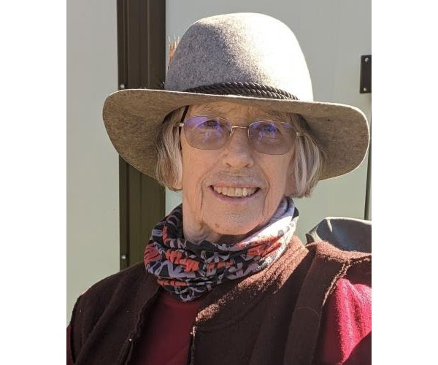

Alison was born in Wilmington, Delaware in 1934 and moved with her family to Canada in 1939. She earned her BA in History at Smith College, her teaching certificate at the Ontario College of Education, and her MA (1955) and PhD (1974) at the University of Toronto. She completed the latter while raising two sons, teaching History and French in Toronto secondary schools, and working as a teaching assistant at the University of Toronto and the Ontario Institute for Studies in Education, then as a lecturer, later Assistant Professor at Atkinson College, York University. While at Atkinson, Alison developed and taught one of the first university courses in Canada on women’s history. When she moved to the Ontario Institute for Studies in Education in1975 she developed and taught courses in the History of Education to several generations of graduate students, including path-breaking courses that posed feminist questions of education and brought the experiences of women as teachers and students to the centre of scholarly inquiry. In addition to supervising 24 doctoral and 21 MA students, she served on several dozens thesis committees before she retired in 1998. Many of Alison’s graduate students have gone on to make significant contributions to the history of education in Canada and internationally.

Throughout Alison’s impressive career her interests in the history of education were closely linked to her focus on women and gender relations. Thus, she was the founding head of OISE’s Centre for Women’s Studies in Education, working closely with a team of researchers and colleagues on several studies and publications, including the Canadian Women’s History Project, which generated Canadian Women: A History (co-authored with Paula Bourne, Gail Cuthbert Brandt, Beth Light, Wendy Michinson and Naomi Black). Now in its third edition, this book is widely used in Canadian university classrooms. The two volumes of The Neglected Majority: Essays in Canadian Women's History (co-edited with Susan Mann Trofimenkoff), as well as Pioneer and Gentlewomen of British North America (co-edited with Beth Light) made important contributions to Canadian Women’s History. Alison’s scholarly passion to promote a more inclusive and interdisciplinary view of history extended beyond university classrooms to include elementary and secondary school teachers, public historians, community- based settings (such as museums, libraries and galleries) and other informal networks of learning. This led her to co-found the Ontario Women’s History Network (OWHN) in 1990.

Alison not only exceled in her own research and publications, throughout her career she consistently worked to collaborate with and nourish the work of others. Be it in organizations such as Canadian History of Education Association, the Canadian Historical Association or the Ontario Women’s History Network, she took every opportunity to conduct collaborative research, to co-author and co-edit books, and to organize conference sessions with colleagues and students. She was an active member of the Canadian Committee on Women’s History (now the Canadian Committee on Women’s and Gender History), affiliated with the Canadian Historical Association.

From the outset of her career Alison’s work had significant scholarly impact. When it was first published in 1977 as The School Promoters: Education and Social Class in Mid-Nineteenth Century Upper Canada, her doctoral thesis became an instant classic in the revisionist history of Ontario education. Other publications brought social history to broad education questions, including two books co-authored or co-edited with Susan E. Houston: Family, School and Society in Nineteenth Century Canada (1975), and Schooling and Scholars in Nineteenth Century Ontario (1988). Schooling and Scholars was awarded the Canadian Association for Foundations in Education Book Prize in 1992.

It was perhaps through her many publications focusing on women teachers, women historians and women in the professions that Alison was best known among historians in Canada and internationally. Thus, during the early 1980s she published several chapters and articles on women teachers with the late Marta Danylewycz, and co-edited (with Ruby Heap) Gender and Education in Ontario: An Historical Reader in 1991. The same year she published an international collection of papers, Women Who Taught: Perspectives on the History of Women and Teaching (co-edited with Australian historian Marjorie Theobald). A few years later, Alison co-edited with Swedish historian Inga Elgqvist-Saltzman and Australian Alison Mackinnon Education into the Twenty-First Century: Dangerous Terrain for Women? Each of these publications, along with numerous articles, chapters and talks drew attention to the complexities of gendered experiences of education and the gendered organization of teachers’ work and lives.

In the mid-1990s Alison turned her interests toward the education of women in the professions, including the experiences of women in physics and history. Again she worked collaboratively with colleagues to stimulate debate and research and to bring work to publication. A book on women historians Creating Historical Memory: English-Canadian Women and the Work of History, published in 1997, was co-edited with Beverly Boutilier. A collection of papers on women’s professional work, Challenging Professions: Historical and Contemporary Perspectives on Women's Professional Work, was co-edited with Elizabeth Smyth, Sandra Acker and Paula Bourne, and published in 1999.

Alison was made a Fellow of the Royal Society of Canada in 1998. While she was pleased that her scholarship was recognized, she wrote a letter to the Society to complain about their use of the term ‘fellow’ in doing so. Her outstanding contributions were further recognized in 2013, when she became a Member of the Order of Canada. She received honorary doctorates from the University of Guelph and Western University, and awards from many associations, including the Canadian Historical Association, the Canadian Association of Foundations of Education, and the Canadian History of Education Association. The Ontario Historical Society established the Alison Prentice prize for the best book in Women’s History, first awarded in 1998. In 1990 Alison, along with her co-authors of Canadian Women: A History, received Women of Distinction Awards from the Toronto YWCA for the writing of this text.

Well into retirement and after she moved to Victoria, B.C. Alison maintained her involvement in networks of historians and scholars and she actively continued her historical research and published more than a dozen articles, chapters and reviews. Alison and Jim were Quakers, activists for social justice, and passionate environmentalists. They spent much of their time outdoors and were avid canoeists, sailors and skiers, as well as welcoming hosts in Toronto and Victoria, as well as in Collingwood, Cedar Island, and Lasqueti Island. In 2020, Alison published Adventures With Jim, a memoir created from Jim’s collection of letters, journal entries and photographs. It is a beautiful testament to their long life together, and to lives lived with compassion and adventure.

As her student, colleague and friend Elizabeth Smyth wrote: “Always humble, caring and thoughtful, Alison paired a brilliant mind with a compassionate personality. She was a legend. She was a star.”

Alison was predeceased by her son, Matthew, and her husband, Jim Prentice, who was a physicist at the University of Toronto. She leaves her son, Douglas, and two grandsons, Theo and Guthrie, extended family, and wide circle of friends and colleagues. A celebration of Alison’s life will be organized in Victoria in a few weeks, allowing for both in-person and virtual participation. Those who wish to send condolences or memories to Alison’s family can address them to her son, Doug.

Douglas Prentice
1144 North Park St.
Victoria, BC, V8W 3Y3

Email: dougprentice3.1416@yahoo.com

https://www.legacy.com/obituaries/timescolonist/obituary.aspx?n=alison-leeds-prentice&pid=199318707

Tribute by Kari Dehli, Paula Bourne, Elizabeth Smyth and Harry Smaller

